
In Linux systems, large volumes of data are often stored in text files such as logs, configuration files, and scripts. Manually searching for specific information inside these files is inefficient and error-prone. Linux provides powerful text-searching utilities that enable users to quickly locate patterns, keywords, or strings within files and command outputs.
The problem is to search for specific patterns and text within files using Linux commands such as grep, fgrep, and related options, and to understand their importance in log analysis, troubleshooting, and automation tasks.

Theory

Text Searching in Linux
Linux treats most data as plain text, making text-processing tools extremely powerful. Searching text efficiently is essential for:
- Log file analysis
- Configuration troubleshooting
- Security monitoring • Automation scripts

grep Command
The grep command searches for a pattern in files or input streams and prints matching lines.
Basic syntax:
grep [options] pattern filename

Related Commands
- grep – General pattern searching
- fgrep – Fast grep (searches fixed strings, no regular expressions)
- egrep – Extended grep (supports extended regular expressions)
Note: In modern Linux systems, egrep and fgrep are implemented using grep -E and grep -F.

Commands Used
grep | Search text using patterns
grep -i | Case-insensitive search
grep -n | Show line numbers
grep -r | Recursive search
grep -v | Invert match
fgrep | Search fixed strings
cat | Display file content
ls | List files

Procedure
- Log in to the Linux system and open the terminal.
- Create a working directory:
mkdir grep_lab cd grep_lab
- Create a sample text file:
nano sample.txt
- Add content to files using redirection:
Linux is powerful
Linux is secure
Bash scripting is useful Cyber Security uses Linux
- Display file contents:
cat file1.txt
- Search for a word using grep:
grep Linux sample.txt
- Perform case-insensitive search:
grep -i linux sample.txt
- Display line numbers with matches:
grep -n Linux sample.txt
- Invert the match:
grep -v Linux sample.txt
- Search using fgrep:
fgrep "Bash scripting" sample.txt
- Perform recursive search (if multiple files exist):
grep -r Linux .

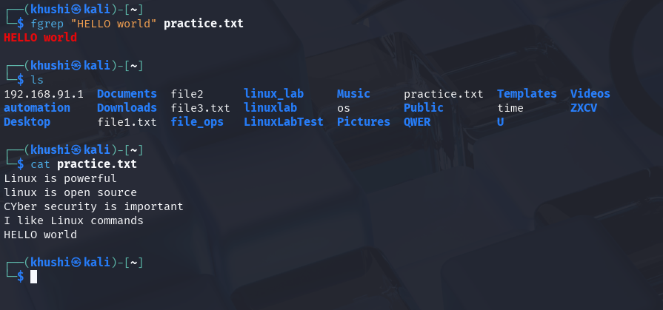

Result
Text searching operations were successfully performed using grep and related commands. The student gained practical experience in locating specific patterns within files, which is essential for log analysis and automation tasks.

